Memorandum
To: Ridgefield Public Safety Facilities Committee
From: Kirk Carr
Date: March 11, 2026
Subject: Considerations for Evaluating Options for Ridgefield Public Safety Facilities

Introduction
The purpose of this memorandum is to offer several observations and suggestions that may assist the Committee in its work evaluating options for Ridgefield’s police and fire facilities. It unpacks the original RFP and the Committee’s charge for greater clarity.
The Committee has been given an important responsibility: to recommend a plan that both addresses operational needs and garners the confidence and support of Ridgefield voters. The defeat of two recent referendums suggests that, while there is broad agreement that the facilities need improvement, the community has not yet been convinced that the proposed solution represented the best path forward.
Accordingly, the Committee’s work represents an opportunity to evaluate options in a manner that is transparent, analytically rigorous, and responsive to public concerns.

1. Relationship Between the Original RFP and the Committee Charge
The 2019 Request for Proposals (RFP) that initiated the previous process and the current charge to this Committee share several similarities but also important differences.

Similarities
Both documents emphasize:
• Evaluating the condition and future needs of the Police and Fire Departments
• Identifying facility options that meet operational requirements
• Developing recommendations for capital investment
Both assume that some level of facility investment will be necessary.

Differences
The RFP was a technical planning document, while the Committee’s charge is more process-oriented.
Key differences include:

RFP Focus
The RFP directed consultants to:
- Assess existing facilities
- Project future operational needs
- Develop facility concepts
- Evaluate several development scenarios
The RFP focused heavily on facility design and capacity planning.

Committee Charge Focus
The Committee charge emphasizes:
• public engagement
• evaluation of previous proposals
• development of recommendations acceptable to the community
This reflects the lesson that technical feasibility alone is not sufficient—public acceptance is essential.

2. Options Outlined in the Original RFP

The RFP mandated the development of several facility scenarios. If these alternative scenarios were developed as part of the original study, they have not yet been widely circulated in public discussions. While the exact terminology varied, the options generally included:

Option 1 – Renovate Existing Facilities
• Upgrade existing police and fire facilities
• Address code deficiencies and operational needs
• Expand where feasible
This option focuses on modernizing current locations.

Option 2 – Renovate and Expand with Additional Facilities
• Renovate existing facilities
• Construct additional facilities where needed
This approach could include additional fire stations or satellite facilities.

Option 3 – New Combined Public Safety Facility
• Consolidate police and fire departments
• Construct a new facility on a new site
• Replace existing facilities
This is the concept that ultimately evolved into the combined public safety building proposals presented to voters.

Hybrid Options
The RFP also anticipated combinations of the above approaches, depending on operational analysis.
It is worth noting that a 2008 proposal contemplated a modest expansion of the existing police station of approximately 7,200 square feet. That effort did not proceed, but it illustrates that renovation and expansion of the current facility have long been part of the range of potential solutions.

3. A Missing Baseline: The “Do Nothing / Minimum Intervention” Scenario
One notable omission from both the RFP analysis and subsequent discussions is a formal evaluation of the baseline scenario:
Do nothing beyond essential repairs.
In capital planning, this is commonly referred to as the “no-build” or “minimum intervention” scenario.
Including this baseline is important for several reasons:
- It establishes a reference point for evaluating proposed investments.
- It clarifies the costs and risks of maintaining current facilities.
- It helps demonstrate the incremental value of proposed solutions.
While doing nothing indefinitely may not be realistic, evaluating this scenario allows decision-makers to understand the true costs and benefits of alternative investments.

4. The 35-Year Planning Horizon
The RFP specifies a 35-year planning horizon for facilities.
While long-term thinking is valuable, this assumption raises several questions.

Comparison to Local Planning Frameworks
Ridgefield’s Plan of Conservation and Development (POCD) operates on a 10-year planning horizon.
Projecting operational requirements three and a half decades into the future requires assumptions that are largely speculative and unreliable. The risks associated with overbuilding can’t be easily fixed later and exceed the risks of underbuilding that can be mitigated with scalability and adaptability.

Population Trends
Available demographic data show that:
• Ridgefield’s population peaked around 2015 at 25,505
• The population has since stabilized at around 25,000 residents

Source: Ridgefield Comprehensive Annual Financial Reports.
The town is geographically constrained at 34.5 square miles. That and infrastructure, topography, soils, and watershed are limiting factors to future population expansion.
These trends and factors establish that Ridgefield is best characterized as a mature community with stable population levels, rather than a rapidly growing municipality.

Accordingly, facility planning will benefit from focusing on:
• current operational needs
• adaptable solutions
• scalable investments
rather than planning for highly speculative growth decades into the future.

5. The Importance of a Clear Value Proposition
One of the key questions raised during the referendums was:
What tangible value does the proposed investment deliver to taxpayers?
Facilities that improve working conditions for public safety personnel are important, but voters also expect to understand how those investments benefit the broader community.
Possible community priorities and benefits could include:
• improved response times
• improved life-saving time-to-intervention
• improved property protection
• reduced fire loss
• improved insurance ratings
• lower insurance premiums
Insurance savings are one of the few public safety benefits that produce direct and measurable financial value for taxpayers, and therefore deserve careful consideration.
Clearly articulating these benefits is essential to gaining public support.

6. Insurance Ratings and Potential Savings
Ridgefield takes pride in its reputation as the safest community in Connecticut.
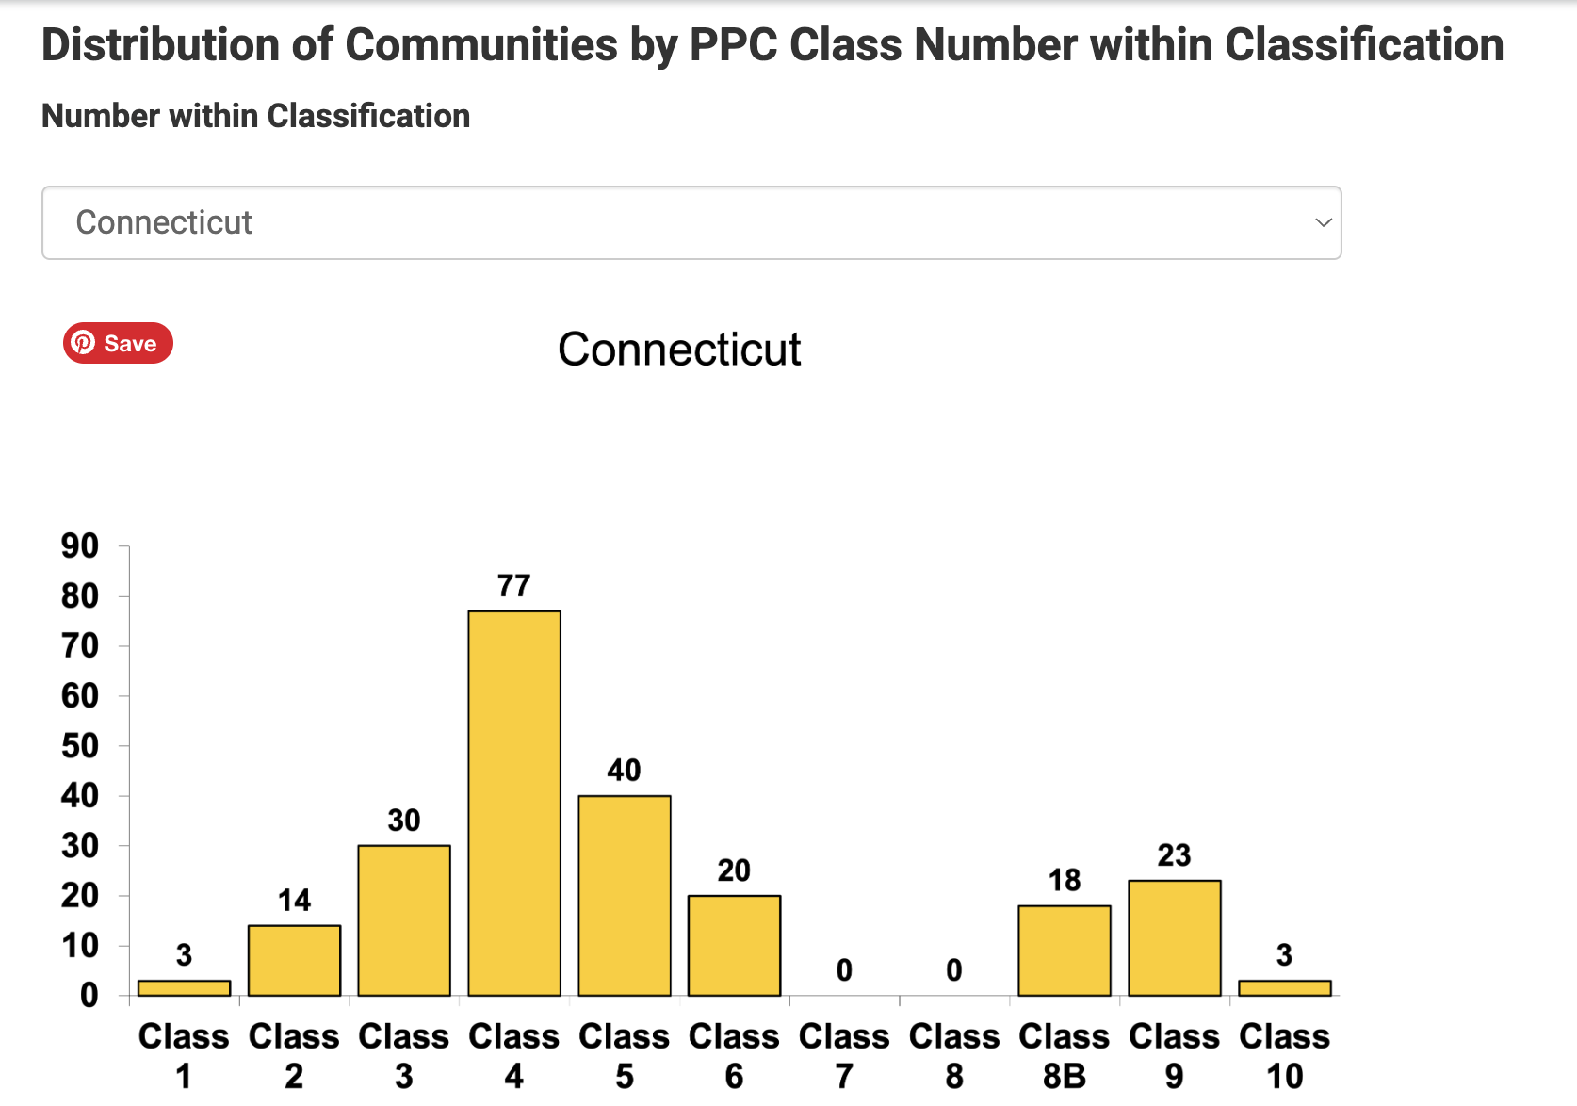
However, the town’s Insurance Services Office (ISO) Public Protection Classification (PPC) is currently: 5 / 5X This rating places Ridgefield below the median of Connecticut communities.

Source: Verisk, Insurance Service Office, 2026.
Improving the town’s PPC rating—through enhanced facilities, deployment, or water supply—could potentially generate:
• lower homeowner insurance premiums
• lower commercial insurance premiums
• economic benefits for local businesses
These potential benefits should be weighed and communicated when evaluating facility investments.

7. Fire Station Coverage in Ridgefield
Ridgefield currently operates two fire stations.
Given the town’s size:
• 34.5 square miles
• 25,000 residents

This level of station deployment is below the norm when compared to other Connecticut municipalities. Ridgefield, with 2 fire stations covering 34.5 square miles or 17 square miles per fire station, which compares with a median of 9 square miles per fire station among Connecticut’s 169 municipalities and 8 square miles per fire station for the state as a whole.
That equates to one fire station for 12,650 people in Ridgefield, compared to a median of just 4,078 people per fire station among the 169 Connecticut municipalities and 5,769 people per fire station statewide.
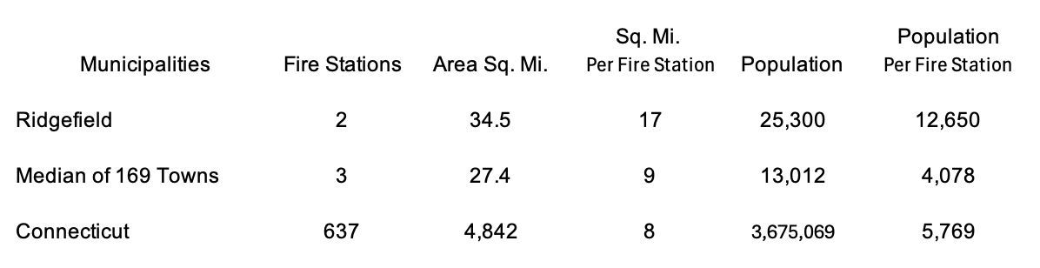
Source: Byte Scrapper Dataset.
These comparisons illustrate that a third station would fall well within the typical range for municipalities of similar size. If Ridgefield’s population grows, a fourth station could be a consideration in the future.
Such an option may also improve:
• geographic coverage
• response times
• traffic congestion conflicts
• deployment flexibility
particularly in areas with high call volumes.
Identifying a suitable location for a smaller satellite station would be less complex than assembling land for a large, combined facility that is oversized for a highly speculative 35-year horizon.

The central question before the Committee is not simply what facility should be built, but which investment delivers the greatest improvement in public safety outcomes and taxpayer value relative to its cost.

8. A Balanced Scorecard Approach
One method that may help the Committee evaluate and communicate options objectively is the Balanced Scorecard framework, which assesses alternatives across multiple dimensions.
A possible framework could include:

Community Value
• response times
• coverage
• life-saving time-to-intervention
• property protection
• insurance impacts

Financial Stewardship
• capital cost
• lifecycle cost
• operating cost
• staggered capital investment
• debt burden

Operational Effectiveness
• deployment efficiency
• apparatus access
• facility functionality

Workforce Sustainability
• recruitment and retention
• training capacity
• health and safety

Balanced Scorecard – Ridgefield Public Safety Facilities (Illustrative Placeholder Values)
This table illustrates how a Balanced Scorecard could compare different facility options. Values are illustrative placeholders only and should be replaced with actual analysis.
Metric | Baseline (Do Nothing / Minimum Fixes) | Option 1 – Renovate Existing Facilities | Option 2 – Renovate + Add 3rd Fire Station | Option 3 – Combined Public Safety Facility
Capital Cost | $0–$2M repairs | $25–$35M | $40–$50M | $70–$85M
Total Cost w/ Interest (30 yrs) | $0–$3M | $45–$60M | $65–$80M | $100–$120M
Avg Fire Response Time | 6.4 min | 6.4 min | 5.4 min | 6.3 min
Coverage of East‑Side Calls | Unchanged | Unchanged | Improved | Negligibly Better Zero Sum
Emergency Traffic Conflicts | Current levels | Current levels | Reduced | Potentially increased
ISO/PPC Rating Potential | 5/5X | 5/5X | 3–4 range* | 5/5X
Estimated Insurance Savings | $0 | $0 | $200–$500/home ($3 Million)* | $0
Energy Efficiency | Poor | Improved | Improved | Best
Maintenance Cost (Annual) | $500K+ | $300K | $320K | $250K
Recruitment / Retention | Challenging | Improved | Improved | Improved
Operational Flexibility | Limited | Moderate | High | Moderate
System Redundancy** | Low | Low | High | Low
*Achieving a better PPC rating may require water or other improvements as well.
** Redundancy is often beneficial in public safety.
Such a framework can help the Committee evaluate options in a structured and transparent manner.

Conclusion
The Committee has the opportunity to approach this challenge in a way that integrates:
• operational needs
• fiscal responsibility
• community priorities
• long-term adaptability
By carefully evaluating multiple options—including comparative baseline conditions—and clearly articulating the value delivered to both public safety personnel and taxpayers, the Committee can help develop a proposal that meets operational needs and that garners the confidence and support of Ridgefield voters.
The original RFP mandated the development of a variety of scenarios that may or may not have ever been accomplished.
The central question before the Committee is not simply what facility should be built, but which investment delivers the greatest improvement in public safety outcomes relative to its cost.

The previous proposals were developed through a traditional facilities planning process. The Committee now has an opportunity to build on that work by evaluating options through a broader lens—one that integrates operational needs, fiscal stewardship, community value, and long-term adaptability. Doing so may help produce a proposal that not only solves facility challenges but also earns the durable support of Ridgefield voters.

